A project Report
On

“Real-Time Face Mask Detection using OpenCV in Python”
Submitted to
Savitribai Phule Pune University, Pune
In fulfilment of Project Work
in
Bachelor of Engineering
In
Second Year Engineering
By
Dhruv Dhananjay Morey (Roll No : 43)
Under the Guidance of
Dr. Nikita Kulkarni

Department of Computer Engineering
AY- 2020-21

Trinity Academy of Engineering, Pune

CERTIFICATE
This is to certify that Dhruv Dhananjay Morey Roll 43 has successfully completed Project Based Learning II entitled Real-Time Face Mask Detection using OpenCV in Python under my supervision in the fulfilment of Second YearEngineering in academic Year 2020-21 as prescribed by Savitribai Phule Pune University.
.
Date : May 2021 | Dr. Nikita Kulkarni
Place : Pune | Associate Professor  Computer Engineering  Guide
Dr. Nikita Kulkarni | Dr. Nilesh J. Uke
Head of the Department | Principal
Computer Engineering | Trinity Academy of Engineering

Acknowledgment
I would like to acknowledge all the people who have been of the help and assisted me throughout my seminar work.
First of all I would like to thank my respected guided & HOD, Dr. Nikita Kulkarni, Introducing me throughout features needed. The time-to-time guidance, encouragement, and valuable suggestions received from her are unforgettable in my life. This work would not have been possible without the enthusiastic response, insight, and new ideas from him.
Furthermore, I would like to thank respected Principal, Dr. Nilesh Uke for his valuable guidance, support provided by him during my project work. I am also grateful to all the faculty members of Trinity Academy of Engineering, Pune for their support and cooperation. I would like to thank my lovely parents for time-to-time support and encouragement and valuable suggestions, and I would specially like to thank all my friends for their valuable suggestions. The acknowledgement would be incomplete without mention of the blessing of the Almighty, which helped me in keeping high moral during most difficult period.
Dhruv Dhananjay Morey
Roll No: 43

Contents
Certificate 2
Acknowledgment 3
1 Introduction ............................ 7
  - Background of your work ............................ 7
  - Basic Concept Explanation ............................ 8
  - Problem Statement ............................ 9
  - Objective ............................ 10
2 Project Title ………………….13
3.1 System Architecture
3.2 Explanation of all modules
3 Conclusion ............................ 26

Chapter 1
  - Introduction to Real-Time Face Mask Detection using OpenCV in Python

In this project we are going to learn how to implement face mask detection problem. Today it has become mandatory for all the citizens to wear a face mask to protect themselves from COVID-19. This application can be helpful for all the shop owners, offices, banks or any public place because if anyone is not wearing a mask then he or she must not be allowed in that area. So, to take care of this problem we don’t need any guard or person who keeps a watch on people. We can integrate a camera which continuously clicks pictures of humans and detect from there faces whether they are wearing a face mask or not.

1.2 Data Classification
Feature Base Approach
Objects are usually recognized by their unique features. There are many features in a human face, which can be recognized between a face and many other objects. It locates faces by extracting structural features like eyes, nose, mouth etc. and then uses them to detect a face. Typically, some sort of statistical classifier qualified then helpful to separate between facial and non-facial regions. In addition, human faces have particular textures which can be used to differentiate between a face and other objects. Moreover, the edge of features can help to detect the objects from the face. In the coming section, we will implement a feature-based approach by using OpenCV.

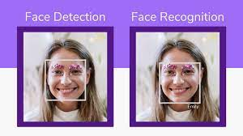

Image Base Approach
In general, Image-based methods rely on techniques from statistical analysis and machine learning to find the relevant characteristics of face and non-face images. The learned characteristics are in the form of distribution models or discriminant functions that is consequently used for face detection. In this method, we use different algorithms such as Neural-networks, HMM, SVM, AdaBoost learning. In the coming section, we will see how we can detect faces with MTCNN or Multi-Task Cascaded Convolutional Neural Network, which is an Image-based approach of face detection

1.3 Machine Learning
Many algorithms are involved to solve the ranking problem. Most of the ranking algorithms fall under the class of “Supervised Learning” which would need a training set consisting of resumes graded by an expert. As we saw earlier, this task is quite difficult as the grade will not only depend on the candidate profile but also on the job requirements. Moreover, we can’t afford the luxury of a human expert training the algorithm for every job opening. We have to use data that is easily available without additional efforts. We do have some data from every job opening as hiring managers screen resumes and select people for interviews. It’s easy to extract this data from any ATS (Applicant Tracking System). Hence we decided to use “Logistic Regression” that predicts the probability of a candidate being shortlisted based on the available data.

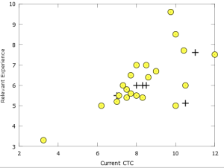
Figure 1.2: Extraction of data using ML

1.4 OpenCV
OpenCV (Open Source Computer Vision Library: http://opencv.org) is an open-source library that includes several hundreds of computer vision algorithms. The document describes the so-called OpenCV 2.x API, which is essentially a C++ API, as opposed to the C-based OpenCV 1.x API (C API is deprecated and not tested with "C" compiler since OpenCV 2.4 releases)
OpenCV has a modular structure, which means that the package includes several shared or static libraries. The following modules are available:
- Core functionality (core) - a compact module defining basic data structures, including the dense multi-dimensional array Mat and basic functions used by all other modules.
- Image Processing (imgproc) - an image processing module that includes linear and non-linear image filtering, geometrical image transformations (resize, affine and perspective warping, generic table-based remapping), color space conversion, histograms, and so on.
- Video Analysis (video) - a video analysis module that includes motion estimation, background subtraction, and object tracking algorithms.
- Camera Calibration and 3D Reconstruction (calib3d) - basic multiple-view geometry algorithms, single and stereo camera calibration, object pose estimation, stereo correspondence algorithms, and elements of 3D reconstruction.
- 2D Features Framework (features2d) - salient feature detectors, descriptors, and descriptor matchers.
- Object Detection (objdetect) - detection of objects and instances of the predefined classes (for example, faces, eyes, mugs, people, cars, and so on).
- High-level GUI (highgui) - an easy-to-use interface to simple UI capabilities.
- Video I/O (videoio) - an easy-to-use interface to video capturing and video codecs.
- ... some other helper modules, such as FLANN and Google test wrappers, Python bindings, and others
Chapter 2

Machine Learning and Image Processing

3.1 Machine Learning and Image Processing
Machine learning is an application of artificial intelligence (AI) that provides systems the ability to automatically learn and improve from experience without being explicitly programmed. Machine learning focuses on the development of computer programs that can access data and use it learn for themselves.
Machine learning equips computers to learn and interpret without being explicitly programmed to do so. Here, as the "computers", also referred as the "models", are exposed to sets of new data, they adapt independently and learn from earlier computations to interpret available data and identify hidden patterns.
Simply put, machine learning allows the user to feed a computer algorithm an immense amount of data and have the computer analyze and make data-driven recommendations and decisions based on only the input data.

3.1.1 Application Of ML

Medical imaging
In medicine, scientists study the inner structures and tissues of organisms in order to help identify anomalies faster. Image processing used in medical imaging can help produce high-quality, clear images for scientific and medicinal research, ultimately helping doctors diagnose diseases.

Security
A car dealership company, or a shop may install security cameras to monitor the area and record thieves if they appear. But sometimes, images generated by security cameras need to be processed, either by doubling the size or increasing brightness and contrast to make details visible enough to capture important details in it.

Military and defense
An interesting application of Image Processing in Defense is Steganography. Experts can hide a message or an image inside another image, and send the information back and forth without any 3rd party detecting the message.

General image sharpening and restoration
This is probably the most widely used application of Image Processing. Enhancing and manipulating images using tools like Photoshop, or using filters on Snapchat or Instagram to make our photos look better.
If you need to automate and process a massive amount of images, it would be a painfully tedious experience to do this manually. This is where machine learning algorithms can boost the speed of image processing, without losing the end quality we need.

  - Steps Involved in ML
STEP 1 – Data Collection
- The quantity & quality of your data dictate how accurate our model is
- The outcome of this step is generally a representation of data (Guo simplifies to specifying a table) which we will use for training

STEP 2 – Data Preparation
- Wrangle data and prepare it for training
- Clean that which may require it (remove duplicates, correct errors, deal with missing values, normalization, data type conversions, etc.)
- Randomize data, which erases the effects of the particular order in which we collected and/or otherwise prepared our data
- Visualize data to help detect relevant relationships between variables or class imbalances (bias alert!), or perform other exploratory analysis
- Split into training and evaluation sets

STEP 3 – Choose a Model
Different algorithms are for different tasks; choose the right one

STEP 4 – Train the Model
- The goal of training is to answer a question or make a prediction correctly as often as possible
- Linear regression example: algorithm would need to learn values for m (or W) and b (x is input, y is output)
- Each iteration of process is a training step

STEP 5 – Evaluate the Model
- Uses some metric or combination of metrics to "measure" objective performance of model
- Test the model against previously unseen data
- This unseen data is meant to be somewhat representative of model performance in the real world, but still helps tune the model (as opposed to test data, which does not)

STEP 6 – Parameter Tuning
- This step refers to hyperparameter tuning, which is an "artform" as opposed to a science
- Tune model parameters for improved performance
- Simple model hyperparameters may include: number of training steps, learning rate, initialization values and distribution, etc.

STEP 7 – Make Predictions
Using further (test set) data which have, until this point, been withheld from the model (and for which class labels are known), are used to test the model; a better approximation of how the model will perform in the real world.
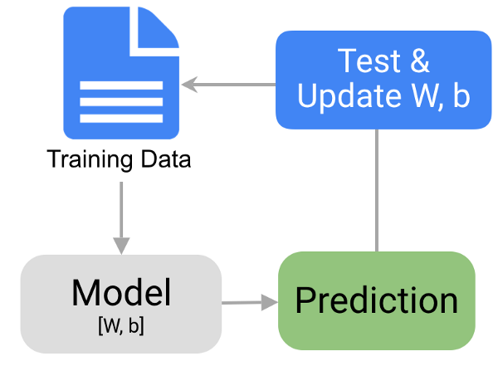

3.3 OpenCV

OpenCV's application areas include:
2D and 3D feature toolkits
Egomotion estimation
Facial recognition system
Gesture recognition
Human–computer interaction (HCI)
Mobile robotics
Motion understanding
Object detection
Segmentation and recognition
Stereopsis stereo vision: depth perception from 2 cameras
Structure from motion (SFM)
Motion tracking
Augmented reality

To support some of the above areas, OpenCV includes a statistical machine learning library that contains:

Boosting
Decision tree learning
Gradient boosting trees
Expectation-maximization algorithm
k-nearest neighbor algorithm
Naive Bayes classifier
Artificial neural networks
Random forest
Support vector machine (SVM)
Deep neural networks (DNN)



Chapter 3

Conclusions
In this work, we have presented an efficient approach to evaluate if a person is wearing a mask or not by processing their face by the concept of Image processing through OpenCV. The success, efficiency of execution, and quality of your projects may depend on many factors, but choosing the right tools is one of the most important – it allows you to significantly save time and resources and get the best results. With the knowledge of machine learning tools for image processing, you can solve these kinds of problems easier, faster, and more efficiently.

